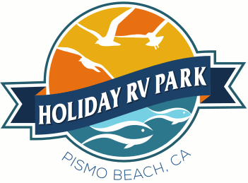
Agenda
Holiday RV Park
Owners Association Meeting
August 12, 2017
Saturday
9:00 am

Call to Order John Watkins
Flag Salute TBD
Roll Call Jon Mackenzie
Minutes to Previous Meeting Jon Mackenzie
Correspondence Leroy Laird
President’s Address John Watkins

Committee Reports

Financial Reports Terry Redwine
Management Tony Damiano
Collections Tom Barcellos
Park Use Fernando DaSilva
Park Maintenance Brien Carlson
Rules & Regulations Charles Nunes
Public Relations / Publicity Leroy Laird
Beach Social Club
Manager Report Julie Hill-Taylor

Old Business

- Park Website Jon M & John W
- Roads Charles Nunes
- One Year Agreement John Watkins
- Assessments in Collections Tom Barcellos
- Rental Agreement Review John Watkins

New Business

- Maintenance Issue Brien Carlson
- Rules & Regulations Charles Nunes
- IT Company RFP John W & Terry R.
- Camp CA 2018 Advertising Julie Hill-Taylor

Owner’s Comments

All Motions

Executive Session

- Personnel

