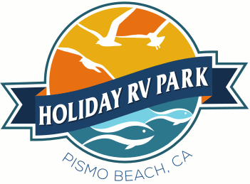
Agenda
Holiday RV Park
Owners Association Meeting
September 9, 2017
Saturday
9:00 am

Call to Order John Watkins
Flag Salute TBD
Roll Call Jon Mackenzie
Minutes to Previous Meeting Jon Mackenzie
Correspondence Leroy Laird
President’s Address John Watkins

Committee Reports

Financial Reports Terry Redwine
Management Tony Damiano
Collections Tom Barcellos
Park Use Fernando DaSilva
Park Maintenance Brien Carlson
Rules & Regulations Charles Nunes
Public Relations / Publicity Leroy Laird
Beach Social Club
Manager Report Julie Hill-Taylor

Old Business

- Roads Charles Nunes
- Assessments in Collections Tom Barcellos
- Rental Agreements Review John Watkins
- Maintenance Issue Brien Carlson
- Rules & Regulations Charles Nunes

New Business

- Street Sweeper Julie Hill-Taylor
- 2018 Budget/Capitol Budget Terry Redwine
- Spectrum Survey Julie Hill-Taylor
- Walkie-Talkies Julie Hill-Taylor
- Electrical Conversion Brien Carlson
- SnowBird Rules & Use of time

Owner’s Comments

All Motions

Executive Session

- Personnel

